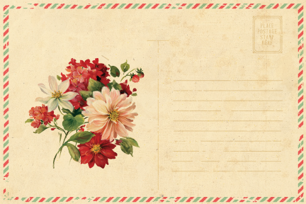

[Phone Number]

|  |  |  |  |  |  |
| --- | --- | --- | --- | --- | --- |
|  | [Logo] |  |  |  |  |
|  |
|  | | | From: | |
|  | |
|  | |
|  | |
|  | |
|  | |
|  | |
|  | |
|  | |
|  | |
|  | |